Answers: Radioactive Dating Assignment
Element: made of same atoms, matter that makes up everything in universe
Atom: smallest part of element
Nucleus: center of atom; contains protons and neutrons
Parent nucleus: radioactively decaying isotope (unstable)
Daughter nucleus: a stable atom that the parent isotope changes into
Isotope: unstable atom with too few or too many neutrons
Absolute age: exact age
Relative age: a comparison of age between a known item and unknown
Probability: chance something will occur based on averages
Constant rate: same amount of time (continual)

2. Draw a picture that represents radioactive decay.
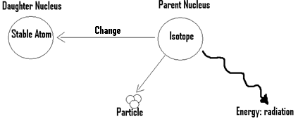

3. How do geologists know the age of the Earth?
They use the radioactive decay rates of elements to tell how old rocks are

4. In radioactive dating, what do the scientists look for or measure?
They measure how much of the element has change from parent to daughter (i.e., Half-life)

5. What is a half-life?
Time it takes for half (i.e., 50%) of an element to breakdown or change from parent to daughter

6. Explain what the statement, “radioactive decay is a random process,” means.
Scientist don’t know exactly when an individual atom will decay (change from parent to daughter) because it is random. However, they can use probability to find out when (i.e., how long) it will happen.

7. Explain why each half-life takes the same amount of time (i.e., constant rate), even though you have less atoms every half-life (i.e. 50% less).
The half-life is based on probability (averages), for this reason it is impossible to know when each atom will change, only when the average amount of time it takes for half the atoms to change. For this reason, the amount of time is constant for each half-life.

8. If each half-life of an element is10 seconds and you had 6.25% of the parent element (nucleus) left, how old is your element?
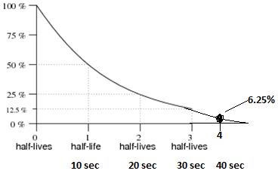
It would take 40 seconds to get to 6.25% parent material leftover.

9. Why do scientists use Uranium or Potassium to study rocks?
It is because Uranium and Potassium have a long half-life (i.e., billions of years). Therefore, scientists can look back to the beginning of the Earth. Also, these elements are abundant in rocks, making them easily to study.

10. Can scientists use carbon-14 to find the absolute age of rocks? Explain why-
No, carbon is not found in large amounts in rocks. Also, carbon is only good for dating organic material over short periods of time, because it has a short half-life (i.e., 5,700 years). For example, the furthest back you could date a tree is up to 60,000 years, because all the isotopes would have decayed by then.

11. How do we know the age of animals and plants that are older than 50,000 years, like dinosaurs?
Mostly, it is done by relative dating. Scientists complete radiometric dating on intrusions of igneous or metamorphic rock. They then use the radiometric date of the intrusion to relatively date the fossil.

12. Can we use radioactive dating on dinosaurs to find their absolute age? Explain why-
No, this is very unlikely. The bones are too old to carbon date and unfortunately, it is very rare to actually even find bones. Most often, dinosaur fossils are actually sedimentary rock, not bones (i.e., mold and cast fossil).

