Finding Average

Student 1 | 23
Student 2 | 33
Student 3 | 45
Student 4 | 25
Student 5 | 23

    - Add up total data = 149
    - Divide by number of subjects/ students = 5 (ex. 100/5=20)
    - 149/5= 29.8 average

Finding Percentage

Student 1 | 23
Student 2 | 33
Student 3 | 45
Student 4 | 25
Student 5 | 23

- Add up the number of like amounts (23, 23 = 2 like amounts)
- Add up the total number of subjects = 5
- Divide total number of like amounts by total number of subjects
- 2/5= 0.4
- Move decimal two places to the left 0.40
- 40% of the students scored a 23

Graphing Cause and Effect Variables
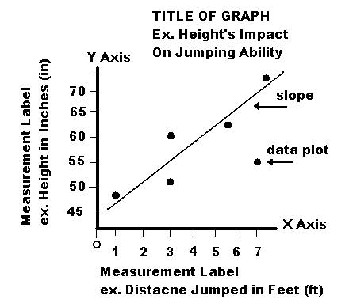
When you are comparing two sets of data measurements against each other (i.e., two variables), a scatter plot graph is useful. For example if you are trying to find out if foot size (variable #1) determines how far you can jump (variable #2). Or if you are trying to determine if the density of a liquid (variable #1) determines how fast you can drink it (variable #2). However for this you would have to figure out the density of the liquids you are using.

EXAMPLE (Creating an X & Y Scatter Plot Graph)

Hypothesis: The bigger the head, the higher the I.Q.

Data Table
Head Size (inches) v. Intellectual Quotient (points)
Student | Head (in) | I.Q. (pts.)
Bob | 25 | 115
Sam | 15 | 105
Kyle | 25 | 120
Jill | 20 | 110

Conclusion: As head size increases, so does I.Q.

