Igneous Rocks
Formations of Rocks at Plate Boundaries: Packet

DO NOT WRITE ON THIS PACKET
PLEASE RETURN AT END OF CLASS

Igneous Rock Formation: Igneous rocks form from the cooling of magma or lava. Molten material cools slowly intrusively (big crystals) or cools quickly extrusively (small crystals)

Convergent Plate Boundary: At convergent plate boundaries, sedimentary rock from the ocean floor gets pushed down into the mantle. The crust increases in temperature as it dives deeper into the mantle, at a subduction zone. Eventually, the crust melts and rises as magma. The magma can cool inside the volcano, creating intrusive igneous rock. It can also erupt from the volcano as lava and cool as extrusive igneous rock. Granite is the most common intrusive igneous rock; it makes the continents and cores of mountains.
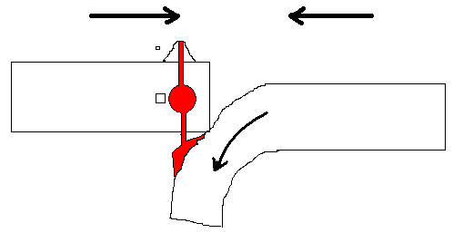
Subduction Zone
Continental Crust
Intrusive igneous rock has large crystals/grains because it cools slowly
Oceanic Crust
[Type a quote from the document or the summary of an interesting point. You can position the text box anywhere in the document. Use the Text Box Tools tab to change the formatting of the pull quote text box.]
Extrusive igneous rock has small crystals/grains because it cools quickly

Divergent Plate Boundary: At diverging plate boundaries, convection currents bring hot magma to the surface. This hot magma flows out onto the ocean floor, forming extrusive, finely grained igneous rocks (i.e., Basalt rock).
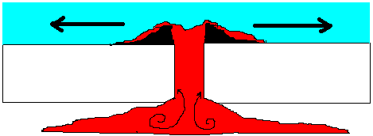
Oceanic Crust
Oceanic Crust

Hot Spot: At hot spots, magma breaks through oceanic crust at weak spots. The magma can cool intrusively or extrusively. This is how the Hawaiian Islands were created. Often this rock is Basalt.
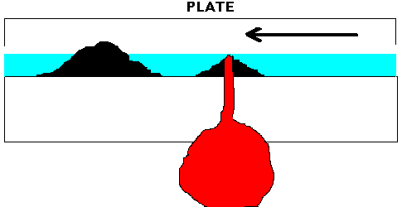
Oceanic Crust
Oceanic Crust
Metamorphic Rocks

Metamorphic Rock Formation: rock made by heat and pressure
Metamorphic rocks form when rocks change after undergoing extreme pressure or a temperature increase. These temperature changes must be hot enough to reorganize matter within the rock but not hot enough to melt the rock. There are two ways in which metamorphic rock is formed (i.e., contact and regional).
- Contact Metamorphism: is localized metamorphism that usually occurs near molten magma or lava, under high temperature and low pressure. When molten rock comes in contact with cooler rock, the rock heats and changes to metamorphic rock. This is often found at divergent plate boundaries and subduction zones. The metamorphic rock tends to be nonfoaliated, because of the low crushing pressures.
- Regional Metamorphism: this metamorphism affects a large area (i.e., regional), and involves intense crushing pressures. This metamorphic rock forms in areas of deep burial, intense lateral pressure (i.e., transform boundaries) and mountain building (i.e., convergent plate boundaries). Most metamorphic rocks are produced by this type of metamorphism (area affected is very large). These rocks are foliated, because of the high crushing pressures.

Convergent Plate Boundary
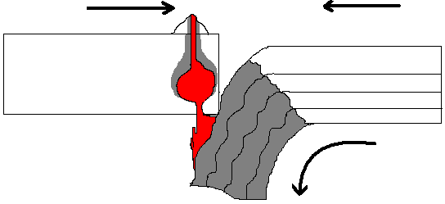
Contact Metamorphism
Regional Metamorphism

Convergent Plate Boundary
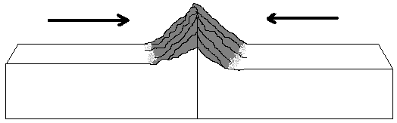
Transform Boundary Divergent Plate Boundary
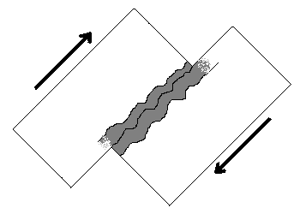
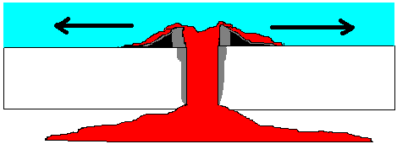

Regional
Metamorphism
Contact Metamorphism

Regional Metamorphism

Sedimentary Rocks

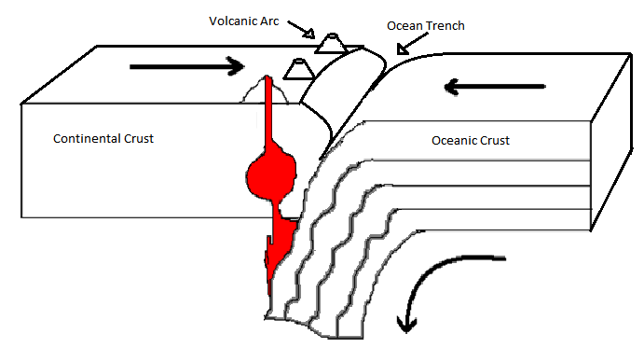
Sedimentary Rock at Active Continental Margin (i.e., Plate): Sedimentary rocks that are comprised of volcanic rock fragments indicate a volcanic source region, and if jagged to angular (e.g., breccia) a short travel history, such as that of an ocean trench next to a volcanic arc.

An active continental margin is found on the leading edge of the continent where it is crashing into an oceanic plate. An excellent example is the west coast of the United States. Active margins are commonly the sites of tectonic activity: earthquakes, volcanoes, mountain building, and the formation of new igneous rock. Because of the mountainous terrain, most of the rivers are fairly short, and the continental shelf is narrow to non-existent, dropping off quickly into the depths of the oceanic trench.

Sedimentary at Passive Continental Margin (i.e., Plate): Well rounded, quartz rich sandstones may represent a beach environment at a passive continental margin.

Passive continental margins are found along coastlines without collision or subduction taking place, tectonic activity is minimal and the Earth's weathering and erosional processes are strong. This leads to lots of low-relief (flat) land extending in both directions from the beach, long river systems, and the accumulation of thick piles of sedimentary debris on the relatively wide continental shelves. The Eastern Seaboard is a passive margin, as is the Gulf Coast. These are the low-relief areas of our continent, and are the locations of such exciting places as New Jersey, the Barrier Islands, the swamps of Florida, and the Mississippi delta.
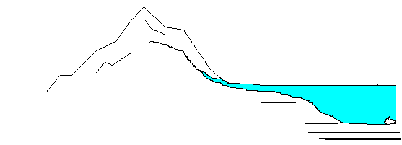

Formations of Different Types of Sedimentary Rocks at Plate Boundaries

The composition and sorting of sedimentary grains provides clues to the sediment source region, transport history and environment of deposition.

Sedimentary rocks that are comprised of volcanic rock fragments indicate a volcanic source region, and if sub-rounded to angular a short travel history, such as that of an ocean trench next to a volcanic arc. Well rounded, quartz rich sandstones may represent a beach environment at a passive continental margin.

Chemically precipitated rocks that have formed due to evaporation (e.g., rock salt, rock gypsum) are possibly remnants of shallow seas in warm arid climates.

Biochemical sedimentary rocks (e.g., chert, fossiliferous limestone) originate in ocean environments when the hard remains of marine organisms collect as sediment. Great ocean depth can be inferred from chert because calcium carbonate has high solubility in colder high pressure environments, typical of the deep oceans.

Formation Process of Sedimentary Rocks

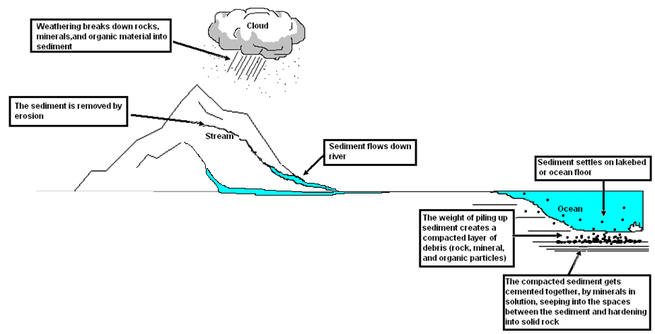
-------------------------------------------------------------------------------------------------------------------------------------------------------
Sedimentary Rock Formation: break, move, drop, squish, and glue
- Weathering: rocks, minerals, and organic materials get broke down.
  - Physical weathering: wind, water, heat, ice, and plants
  - Chemical weathering: chemical reactions (e.g. acid rain, oxidation)
    - Soil: created from weathered rocks and organic material (i.e. dead plants and animals)
- Erosion: the removal of sediments by way of wind, water or ice (i.e. mainly glaciers).
- Deposition: sediments drop out of the wind or water carrying them away.
- Compaction: the squashing together of sediments, caused by layer after layer of heavy sediment stacking up.
- Cementation: the gluing together of sediments by way of minerals seeping into the cracks and hardening.

1. Weathering 2. Erosion 3. Deposition 4. Compaction 5. Cementation
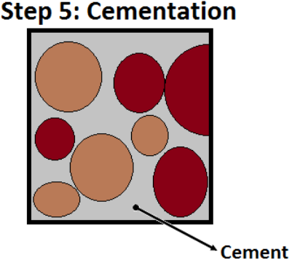
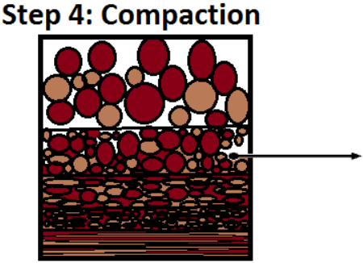
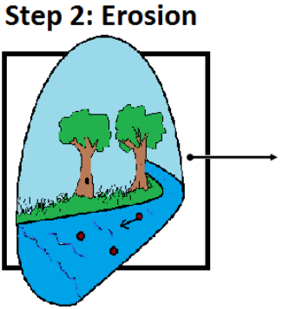
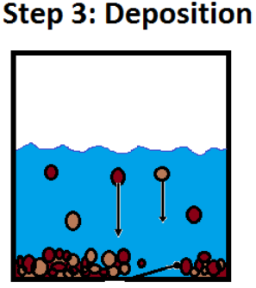
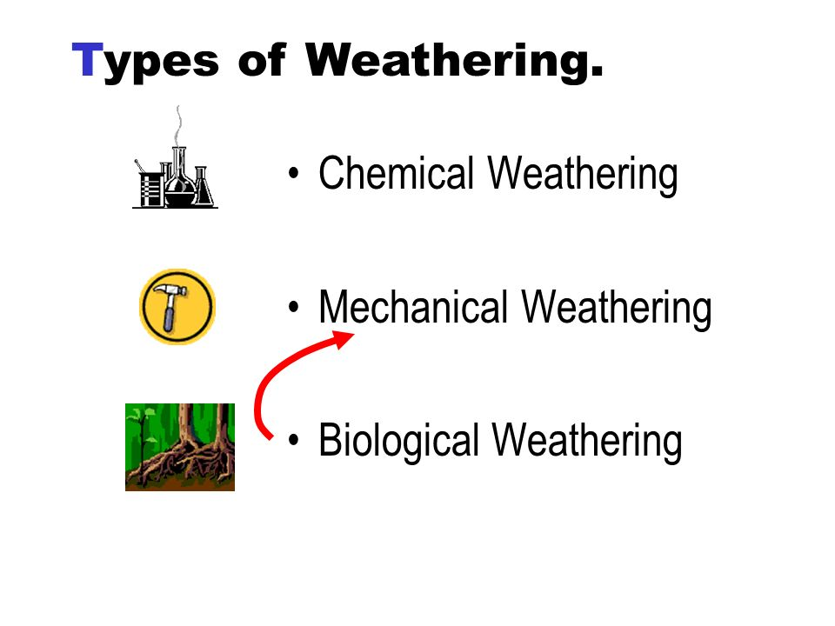

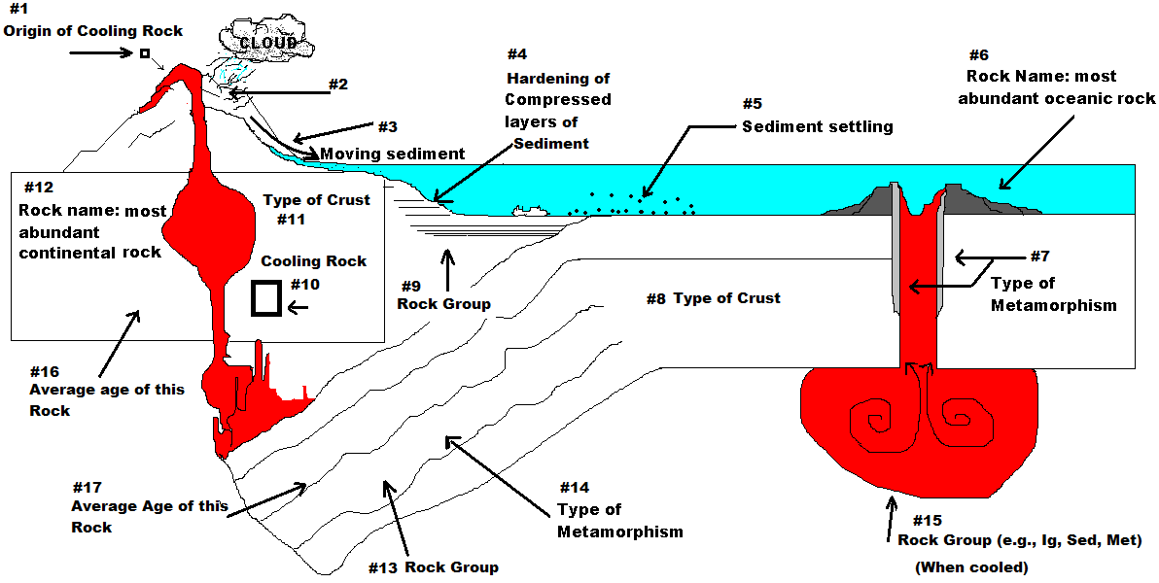

Igneous  Igneous rocks form when molten rock (magma) originating from deep within the Earth solidifies. The chemical composition of the magma and its cooling rate determine the final igneous rock type. | Intrusive  (plutonic) | Intrusive igneous rocks are formed from magma that cools and solidifies deep beneath the Earth’s surface. The insulating effect of the surrounding rock allows the magma to solidify very slowly. Slow cooling means the individual mineral grains have a long time to grow, so they grow to a relatively large size. Intrusive rocks have a characteristically coarse grain size.
 | Extrusive  (volcanic) | Extrusive igneous rocks are formed from magma that cools and solidifies at or near the Earth’s surface. Exposure to the relatively cool temperature of the atmosphere or water makes the erupted magma solidify very quickly. Rapid cooling means the individual mineral grains have only a short time to grow, so their final size is very tiny, or fine-grained Sometimes the magma is quenched so rapidly that individual minerals have no time to grow. This is how volcanic glass forms.
Sedimentary  Sedimentary rocks are formed from pre-existing rocks or pieces of once-living organisms. They form from deposits that accumulate on the Earth's surface. | Clastic | Clastic sedimentary rocks are made up of pieces (clasts) of pre-existing rocks. Pieces of rock are loosened by weathering, and then transported to some basin or depression where sediment is trapped. If the sediment is buried deeply, it becomes compacted and cemented, forming sedimentary rock.  Clastic sedimentary rocks may have particles ranging in size from microscopic clay to huge boulders. Their names are based on their grain size.
 | Chemical | Chemical sedimentary rocks are formed by chemical precipitation. This process begins when water traveling through rock dissolves some of the minerals, carrying them away from their source. Eventually these minerals are redeposited when the water evaporates away or when the water becomes over- saturated.
 | Biologic | Biologic sedimentary rocks form from once-living organisms. They may form from accumulated carbon-rich plant material or from deposits of animal shells.
Metamorphic  Metamorphic rocks are rocks that have been substantially changed from their original igneous, sedimentary, or earlier metamorphic form. Metamorphic rocks form when rocks are subjected to high heat, high pressure, hot, mineral-rich fluids or, more commonly, some combination of these factors. | Foliated | Foliation forms when pressure squeezes the flat or elongate minerals within a rock so they become aligned. These rocks develop a platy or sheet-like structure that reflects the direction that pressure was applied.
 | Non-foliated | Non-foliated metamorphic rocks do not have a platy or sheet-like structure. There are several ways that non-foliated rocks can be produced. Some rocks, such as limestone are made of minerals that are not flat or elongate. No matter how much pressure you apply, the grains will not align! Another type of metamorphism, contact metamorphism, occurs when hot igneous rock intrudes into some pre-existing rock. The pre-existing rock is essentially baked by the heat, changing the mineral structure of the rock without addition of pressure.

