Plate Tectonic Features
Word Bank
-Island Arc -Volcanic (mountain) Arc -Deep-Sea (ocean) Trench -Subduction Zone -Convergent Mountain Range (cont. to cont.)
- Mid-Ocean Ridge -Magnetic Stripes -Hotspot -Continental Rift Valley -Oceanic Crust -Continental Crust

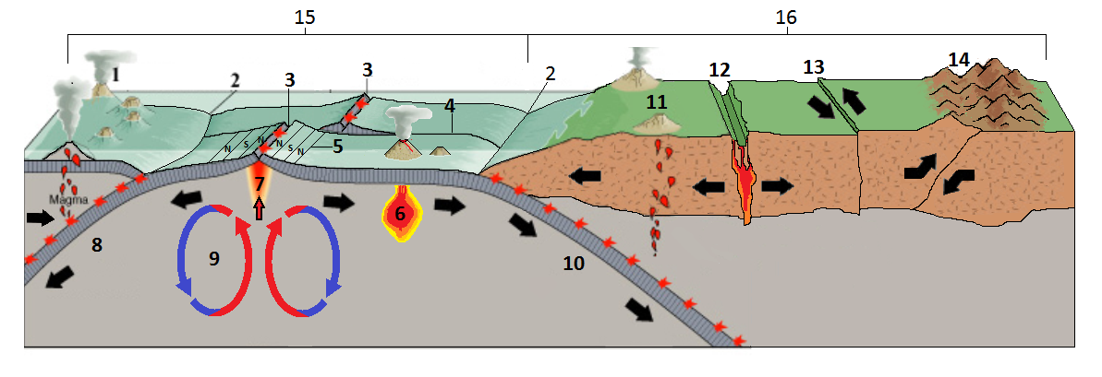

Plate Tectonic Processes and Plate Boundaries
Word Bank
-Sea-Floor Spreading -Convection Currents (mantle) -Subduction
-Convergent Boundary -Divergent Boundary -Transform Boundary

