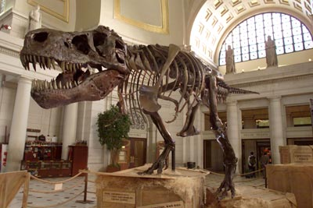
How do scientists determine the age of dinosaur bones?
When paleontologist Mary Schweitzer found soft tissue in a Tyrannosaurus rex fossil, her discovery raised an obvious question -- how the tissue could have survived so long? The bone was 68 million years old, and conventional wisdom about fossilization is that all soft tissue, from blood to brains, decomposes. Only hard parts, like bones and teeth, can become fossils. But for some people, the discovery raised a different question. How do scientists know the bones are really 68 million years old?
The 67-million-year-old Tyrannosaurus rex skeleton known as Sue stands on display at Union Station on June 7, 2000, in Washington, D.C.

Today's knowledge of fossil ages comes primarily from radiometric dating, also known as radioactive dating. Radiometric dating relies on the properties of isotopes. These are chemical elements, like carbon or uranium, that are identical except for one key feature -- the number of neutrons in their nucleus.
Usually, atoms have an equal number of protons and neutrons. If there are too many or too few neutrons, the atom is unstable, and it sheds particles until its nucleus reaches a stable state. Think of the nucleus as a pyramid of building blocks. If you try to add extra blocks to the sides pyramid, they may stay put for a while, but they'll eventually fall away. The same is true if you take a block away from one of the pyramid's sides, making the rest unstable. Eventually, some of the blocks can fall away, leaving a smaller, more stable structure.
The result is like a radioactive clock that ticks away as unstable isotopes decay into stable ones. You can't predict when a specific unstable atom, or parent, will decay into a stable atom, or daughter. But you can predict how long it will take a large group of atoms to decay. The element's half-life is the amount of time it takes for half the parent atoms in a sample to become daughters.
To read the time on this radioactive clock, scientists use a device called a mass spectrometer to measure the number of parent and daughter atoms. The ratio of parents to daughters can tell the researcher how old the specimen is. The more parent isotopes there are -- and the fewer daughter isotopes -- the younger the sample. The half-life of the isotope being measured determines how useful it is at dating very old samples. Once all the parents have become daughters, there's no more basis for comparison between the two isotopes. Scientists can't tell whether the clock ran down a few days or millions of years ago. This means that isotopes with a short half-life won't work to date dinosaur bones. Also, the scientists can only use isotopes that are abundant (i.e., in large amounts). They need a large enough sample for measuring and they need a large sample for probability (i.e. law of large numbers). If the sample is too small, unpredictable things can happen.
The short half-life is only part of the problem when dating dinosaur bones -- researchers also have to find enough of the parent and daughter atoms to measure. Read on to see what it takes to date a fossil and what volcanic ash has to do with it.

Dating Sedimentary Rock
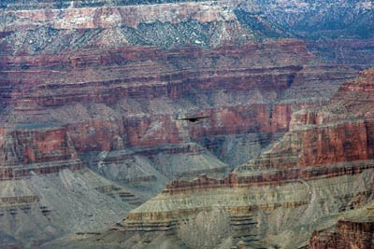
The most widely known form of radiometric dating is carbon-14 dating. This is what archaeologists use to determine the age of human-made artifacts. But carbon-14 dating won't work on dinosaur bones. The half-life of carbon-14 is only 5,730 years, so carbon-14 dating is only effective on samples that are less than 50,000 years old. Dinosaur bones, on the other hand, are millions of years old -- some fossils are billions of years old. To determine the ages of these specimens, scientists need an isotope with a very long half-life. Some of the isotopes used for this purpose are uranium-238, uranium-235 and potassium-40, each of which has a half-life of more than a million years.
Unfortunately, these elements don't exist in dinosaur fossils themselves because of the way fossils form. The most common way for a fossil to form is a mold and cast. In this situation the bone is covered by sedimentary rock and then the bone decays away over time. What is left behind is a mold (i.e. open space) in the shape of the bone. This open space is then filled in by sediment and minerals. Those sediments harden to make a copy or cast of the bone that was once there. Because of this, what you actually have is a sedimentary rock cast and not bone.
An eagle flies over the Grand Canyon in Arizona, April 5, 2007. You can see the layers of sedimentary rock.

Uranium-238, uranium-235 and potassium-40 typically exist in igneous rock, or rock made from cooled magma. Fossils, however, form in sedimentary rock -- sediment quickly covers a dinosaur's body, and the sediment and the bones gradually turn into rock. But this sediment doesn't typically include uranium-238, uranium-235 and potassium-40 in measurable amounts and therefore cannot be used on fossils. Also, fossils can't form in the igneous rock that usually does contain the isotopes. The extreme temperatures of the magma would just destroy the bones.
So to determine the age of sedimentary rock layers, researchers first have to find neighboring layers of Earth that include igneous rock, such as volcanic ash. These layers are like bookends -- they give a beginning and an end to the period of time when the sedimentary rock formed. By using radiometric dating to determine the age of igneous brackets, researchers can accurately determine the age of the sedimentary layers between them.
Using the basic ideas of bracketing and radiometric dating, researchers have determined the age of rock layers all over the world. This information has also helped determine the age of the Earth itself. While the oldest known rocks on Earth are about 3.5 billion years old, researchers have found zircon crystals that are 4.3 billion years old [source: USGS]. Based on the analysis of these samples, scientists estimate that the Earth itself is about 4.5 billion years old. In addition, the oldest known moon rocks are 4.5 billion years old. Since the moon and the Earth probably formed at the same time, this supports the current idea of the Earth's age.
You can learn more about fossils, dinosaurs, radiometric dating and related topics by reading through the links on the next page.

Other Dating Methods
Radiometric dating isn't the only method of determining the age of rocks. Other techniques include analyzing amino acids and measuring changes in an object's magnetic field. Scientists have also made improvements to the standard radiometric measurements. For example, by using a laser, researchers can measure parent and daughter atoms in extremely small amounts of matter, making it possible to determine the age of very small samples

How Carbon-14 Dating Works
You probably have seen or read news stories about fascinating ancient artifacts. At an archaeological dig, a piece of wooden tool is unearthed and the archaeologist finds it to be 5,000 years old. A child mummy is found high in the Andes and the archaeologist says the child lived more than 2,000 years ago. How do scientists know how old an object or human remains are? What methods do they use and how do these methods work? In this article, we will examine the methods by which scientists use radioactivity to determine the age of objects, most notably carbon-14 dating.
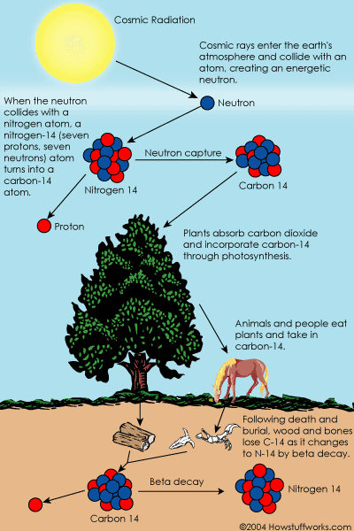
Carbon-14 dating is a way of determining the age of certain archeological artifacts of a biological origin up to about 50,000 years old. It is used in dating things such as bone, cloth, wood and plant fibers that were created in the relatively recent past by human activities.

How Carbon-14 is Made
Cosmic rays enter the earth's atmosphere in large numbers every day. For example, every person is hit by about half a million cosmic rays every hour. It is not uncommon for a cosmic ray to collide with an atom in the atmosphere, creating a secondary cosmic ray in the form of an energetic neutron, and for these energetic neutrons to collide with nitrogen atoms. When the neutron collides, a nitrogen-14 (seven protons, seven neutrons) atom turns into a carbon-14 atom (six protons, eight neutrons) and a hydrogen atom (one proton, zero neutrons). Carbon-14 is radioactive, with a half-life of about 5,700 years.

Carbon-14 in Living Things
The carbon-14 atoms that cosmic rays create combine with oxygen to form carbon dioxide, which plants absorb naturally and incorporate into plant fibers by photosynthesis. Animals and people eat plants and take in carbon-14 as well. The ratio of normal carbon (carbon-12) to carbon-14 in the air and in all living things at any given time is nearly constant. Maybe one in a trillion carbon atoms are carbon-14. The carbon-14 atoms are always decaying, but they are being replaced by new carbon-14 atoms at a constant rate. At this moment, your body has a certain percentage of carbon-14 atoms in it, and all living plants and animals have the same percentage.

Dating a Fossil
As soon as a living organism dies, it stops taking in new carbon. The ratio of carbon-12 to carbon-14 at the moment of death is the same as every other living thing, but the carbon-14 decays and is not replaced. The carbon-14 decays with its half-life of 5,700 years, while the amount of carbon-12 remains constant in the sample. By looking at the ratio of carbon-12 to carbon-14 in the sample and comparing it to the ratio in a living organism, it is possible to determine the age of a formerly living thing fairly precisely.
A formula to calculate how old a sample is by carbon-14 dating is:

t = [ ln (Nf/No) / (-0.693) ] x t1/2
t = [ ln (N_{f}/N_{o}) / (-0.693) ] x t_{1/2}
where ln is the natural logarithm, N_{f}/N_{o} is the percent of carbon-14 in the sample compared to the amount in living tissue, and t_{1/2} is the half-life of carbon-14 (5,700 years).
So, if you had a fossil that had 10 percent carbon-14 compared to a living sample, then that fossil would be:
t = [ ln (0.10) / (-0.693) ] x 5,700 years
t = [ (-2.303) / (-0.693) ] x 5,700 years
t = [ 3.323 ] x 5,700 years

t = 18,940 years old
Because the half-life of carbon-14 is 5,700 years, it is only reliable for dating objects up to about 60,000 years old. However, the principle of carbon-14 dating applies to other isotopes as well.
Potassium-40 is another radioactive element naturally found in your body and has a half-life of 1.3 billion years.
The use of various radioisotopes allows the dating of biological and geological samples with a high degree of accuracy. However, radioisotope dating may not work so well in the future. Anything that dies after the 1940s, when Nuclear bombs, nuclear reactors, and open-air nuclear tests started changing things, will be harder to date precisely. This is due to nuclear reactors and bombs releasing large amounts of radioisotopes.

Other useful radioisotopes for radioactive dating include Uranium -235 (half-life = 704 million years), Uranium -238 (half-life = 4.5 billion years), Thorium-232 (half-life = 14 billion years) and Rubidium-87 (half-life = 49 billion years).

Article: “Dating Sedimentary Rock”
- Why can’t scientists use carbon-14 dating on dinosaur bones?
- Why can’t scientists use uranium-238, uranium-235, and potassium-40 on dinosaur fossils?
- What can scientists use uranium-238, uranium-235, and potassium-40 on?
- Explain why fossils form in sedimentary rock and not igneous.
- Explain why the absolute age of dinosaur fossils cannot be determined, due to the way that fossils commonly form (i.e., cast and mold).
- Explain how scientists use the absolute age of igneous rock (e.g. volcanic ash) to relatively date the sedimentary rock that contains dinosaur bones.
- Explain other dating methods that scientists use.

Article: “How Carbon-14 Dating Works”
- How do scientists know the age of human mummy remains?
- What methods do scientists use to find the age of human artifacts or mummified remains?
- What is the age of the oldest material we can date with carbon-14?
- Why are only certain types of materials dated with carbon-14? (e.g., bone, cloth, wood, plants)
- Explain how carbon-14 isotopes are made.
- Where is carbon-14 found?

Article: “How do scientists determine the age of dinosaur bones?”
- How do scientists determine the absolute age of a specimen (i.e., rock, dinosaur bones, etc.)?
- The author of the article used a pyramid as a metaphor for radioactive decay. What is another metaphor that describes radioactive decay?
- Explain why the amount of isotopes present in a specimen is important (i.e., why size of sample is important).
- Explain why isotopes with a short half-life will not work to date dinosaur bones.

Article: “Dating a Fossil”
- Explain how scientists date fossils with carbon-14 (i.e., what they measure)?
- Why can’t you use carbon-14 on an 80,000 year old tree?
- Why might it be hard to use radioisotopes for dating organic material in the future?

- Explain why C-14 can be used to date a 40,000 year old tree, but Uranium cannot.

