Radioactive Decay and Dating
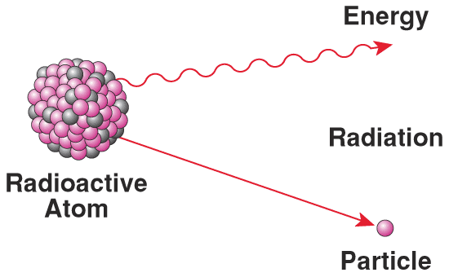
How do geologists know the age of the Earth?
Radioactive Decay: it is the random breakup of an unstable atom, known as an isotope. Particles (e.g., alpha particles & beta particles) and energy shed off from the atom’s nucleus, leaving behind the new element. The nucleus is the center of an atom; where protons and neutrons are found. When the unstable atom falls apart and sheds parts of its nucleus, scientists call this radioactive decay. The energy that is emitted as it decays is called radiation.
What is an isotope?
Isotope: it is an atom with too many or too few neutrons. A stable atom has the same number of protons and neutrons in its nucleus. For example scientists use the unstable element Uranium-235 (i.e., isotope), which breaks down into the stable element Lead-207.
Metaphor for Radioactive Decay: It’s like a pyramid of sand. If it is not perfectly put together, it starts to randomly fall apart and becomes something other than a pyramid. Can you come up with your own metaphor for radioactive decay?
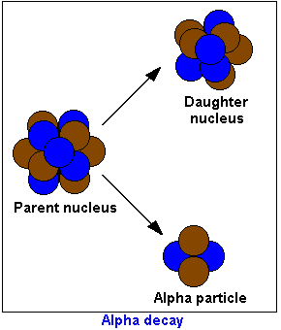
In radioactive dating, what do the scientists look for or measure?
Scientists measure the amounts of parent and daughter nuclei to determine the amount of radioactive decay. If you look at the picture, you can see that the parent nucleus is falling apart and becoming a new element (i.e., daughter nucleolus). Let’s imagine that the parent nucleus is Uranium-238 and it is breaking apart to form the daughter nucleus Lead-206. Scientists can measure how much of a sample is made up of the element uranium (i.e. parent) and how much of the sample is made up of lead (i.e., daughter). Scientists also know how long it takes for this change to occur. They call this timeframe its half-life.
What is half-life?
Half-life: this is how long it takes (sec, hours, years, etc.) for half of the unstable Uranium to turn into the stable Lead.
The half-life has a constant decay. Meaning: The unstable element Potasium-40 takes 1.3 billion years for half of it to turn into a new element. It then takes another 1.3 billion years for the leftover half to turn into the new element and so on. So for it to all turn into Argon-40 it takes tens of billions of years.
Radioactive decay is a random process. The elements fall apart in a similar way to how popcorn pops. Random! Think about how popcorn pops. A bunch of popcorn pops at the beginning and less and less pop as you go on… Why? How did the great popcorn scientist Orval Redenbacher know how long it took to pop a bag of popcorn?
Why does more popcorn pop at the beginning and less at the end of the cooking process? They pop randomly.
Imagine you watch the microwave timer and find that, on average (i.e., the probability), half of the kernels pop every 10 seconds. Well, because probability is constant (i.e., happens at same speed), you know that every 10 seconds you will have 50% less popcorn.
Under the law of large numbers, probability theory states that the more you do something the closer it will be to the average. For example, imagine you have a coin and you flip it over and over. At the beginning you could have many more heads than tails. However, the more you flip the coin the closer you will come to 50% heads and 50% tails. Although the coin toss is random every time, you know the probability of you getting a heads is 50% and a tails is 50%. This is also true for radioactive decay. Even though the atoms decay randomly, scientists know the probability for how long it will take for the atoms to decay. Based on averages (probability) the atoms will decay at a constant rate. Therefore, probability tells scientists how long it takes for half the atoms to decay and that time will be the same no matter how many atoms you have (i.e. each half-life). It is like starting the timer at zero for every half-life. If it takes 10 seconds for the first 50% to change (i.e., decay), it will take 10 seconds for the next 50% to decay (2nd half-life), and so on until all is decayed.
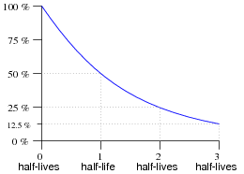
Look at the graph, and imagine that each half-life represents 10 seconds on the microwave timer. Probability states that after 30 seconds (i.e., half-life #3) of popping you should have 12.5% of your popcorn left.
Rate of decay + amount decayed = age of element
Why do scientists use Uranium or Potassium to study rocks?
Simple, Uranium and Potassium have a really long half-life. The half-life of Uranium-235 is 713 million years. That means scientists can use Uranium-235 to look back in time 4.6 billion years (age of planet). However, the most abundant isotope of Uranium is 238 and it has a half-life of 4.468 billion years. That means Uranium-238 that formed at the beginning of the planet has now reached its half-life.
However, scientists can only use radiometric dating on igneous and metamorphic rocks. Unfortunately, sedimentary rocks are made of eroded pieces of metamorphic and igneous rock that formed at different times. Also, it is not a good dating system for organic material, because organic material contains very small amounts of Uranium.
What is Carbon-14?
Carbon-14 is an unstable isotope of the element carbon. It breaks down, releasing particles and energy (radioactivity) and changes to stable nitrogen-14.
Can scientists use carbon-14 to find the absolute age of rocks?
Carbon is found in organic (i.e., living) materials, so you will not find it in igneous and metamorphic rocks. You can only use it on organic material trapped in sedimentary rock to find out a relative age of the rock. However, it is best for dating plants and dead animals. However, it has a short half-life of 5,730. So you can only use it for organic material that formed less than 60,000 years ago.
So how do we know the age of animals and plants that are older than 60,000 years, like dinosaurs? Aren’t fossils found in sedimentary rock and not igneous/metamorphic? Can we use Carbon-14 on dinosaurs? Can we use Uranium-238 on the dinosaurs?
No, we have to look at intrusive igneous rock or metamorphic rock that is stuck in the layers of the sedimentary rock. Once we find out how old the intrusive metamorphic or igneous rocks is with radiometric dating, we then can tell how old the sedimentary rock is and therefore we can find the relative age of the dinosaur trapped inside of the sedimentary rock. Before radioactive dating, scientists would strictly use the law of superposition to find the age of dinosaurs. As for using uranium on dinosaur bones, no we cannot. Unfortunately, uranium is not found in organic material in large enough amounts. Plus, most fossils are not bones, they are actually sedimentary rock (e.g., mold and cast fossil).
Name_______________________________________________________Hour__________Date_______________
Radioactive Decay and Dating
1. Define the following terms:
Element:
Atom:
Nucleus:
Parent nucleus:
Daughter nucleus:
Isotope:
Absolute age:
Relative age:
Probability:
Constant rate:

2. Draw a picture that represents radioactive decay.

3. How do geologists know the age of the Earth?

4. In radioactive dating, what do the scientists look for or measure?

5. What is a half-life?

6. Explain what the statement, “radioactive decay is a random process,” means.

7. Explain why each half-life takes the same amount of time (i.e., constant rate), even though you have less atoms every half-life (i.e., 50% less).

8. If each half-life of an element is10 seconds and you had 6.25% of the parent element (nucleus) left, how old is your element?

9. Why do scientists use Uranium or Potassium to study rocks?

10. Can scientists use carbon-14 to find the absolute age of rocks? Explain why-

11. How do we know the age of animals and plants (i.e., organic matter) that are older than 50,000 years, like dinosaurs?

12. Can we use radioactive dating on dinosaurs to find their absolute age? Explain why-

13. Explain why C-14 can be used to date a 40,000 year old tree, but Uranium cannot.

