Name___________________________________________________________________Hour__________Date__________________

Identifying Rocks Lab
Directions: Use the “Rocks Packet,” rock cards, and sample rocks to identify the following common rocks:
  - Igneous: granite, basalt, andesite, obsidian, and pumice
  - Sedimentary: sandstone (quartz form), limestone, shale, conglomerate, and coal (Bituminous form)
  - Metamorphic: schist, gneiss, marble, slate, and quartzite

Parent/Daughter Metamorphism: To identify parent and daughter metamorphism, look in the “rocks packet” or page 111 in your book.
Contact metamorphism occurs typically around intrusive igneous rocks as a result of the temperature increase caused by the intrusion of magma. Contact metamorphic rocks are usually known as hornfels. Rocks formed by contact metamorphism may not present signs of strong deformation and are often fine-grained.
Regional metamorphism covers large areas of continental crust typically associated with mountain ranges, particularly subduction zones, or the roots of previously eroded mountains. The collision of two continental plates or island arcs with continental plates produce the extreme compressional (i.e., crushing) forces required for the metamorphic changes typical of regional metamorphism. The rock is often foliated or deformed due to the strong crushing pressures.
Igneous Rocks (p. 98-101)
Name |  | Diagnostic Feature |  | Origin  (extrusive or intrusive) |  |  | Grain Size  (fine, coarse, nonvisible or mixed) |  |  | Mineral Composition |  |  | Daughter Metamorphic Rock  (turns into which metamorphic rock) |  |  | Importance or Use |  |  | Plate Boundary  (Convergent, Divergent, Trans., Hotspot) |  | Picture of Rock  (be sure to color)
1. |  | Vesicular (holey)  Light weight & color |  |  |  |  |  |  |  |  |  |  | Variable  Schist possible
2. |  |  |  |  |  |  |  |  |  |  |  |  | Granite intrusion turns to Gneiss
3. |  |  |  |  |  |  | Fine |  |  |  |  |  | Hornfels
4. |  |  |  |  |  |  |  |  |  | Labradorite, augite, olivine |  |  |  |  |  | Oceanic Crust
5. |  |  |  |  |  |  |  |  |  |  |  |  |  |  |  | Continental Crust
Sedimentary Rocks (p. 102-106)
Name | Diagnostic Feature |  | Grain Shape  (weathered/rounded or not weathered/jagged) |  |  | Grain Size  (fine, coarse, or nonvisible) |  | Rock Type  (clastic, organic, or chemical) |  |  | Origin  (Quiet or Active Environment and description of env.) |  |  | Daughter Metamorphic Rock  (turns into) |  |  | Composition  (What the rock is made of) |  | Importance or Use |  |  | Picture of Rock  (be sure to color)
1. |  |  |  |  |  |  |  |  |  |  |  |  |  | Anthracite (metamorphic coal)
2.

3. |  |  |  |  |  |  |  |  |  |  |  |  |  |  |  |  | Clay Minerals
4. | Reactive to Acid  (Carbonate) |  |  |  |  |  |  |  |  |  | Quiet/Passive Environment:  Lake, sea, or underground water
5.

Metamorphic Rocks (p. 110-112)
Name |  | Diagnostic Feature | Grain Pattern  (foliated or nonfoliated) |  | Grain Shape  (round, jagged, or not visible) |  |  |  | Plate Boundary  (Con., Div., Trans., Hotspot) |  |  | Contact or  Regional Metamorphism |  |  | Parent Igneous or Sedimentary Rock  (was) |  |  | Importance or Use |  | Picture of Rock  (be sure to color)
1.

2.

3. |  | Reactive to Acid (Carbonate)
4.

5. |  |  |  |  |  |  |  |  |  |  |  | Regional
Answer Key: Identifying Rocks Lab

Igneous Rocks (p. 98-101)
Name | Plate Boundary | Mineral Composition | Grain Size  (fine, coarse, or nonvisible) | Origin  (extrusive or intrusive) | Daughter Metamorphic Rock | Importance or Use | Diagnostic Feature | Picture of Rock  (be sure to color)
1.  Pumice | Convergent (subduction zone)  -Hotspot | -Silica Mineraloid volcanic glass  (not truly a mineral because no crystalline structure)  -Calcite | Nonvisible  (some crystals can be present) | Extrusive | Variable  Schist possible | Mild abrasive (e.g., lava soap) | -Vesicles (holes)  -Low Density (floats in water)  -Light Color & weight | 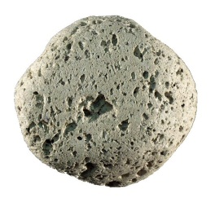
2.  Obsidian | Convergent  (Subduction zone)  -Hotspot | -Silica Mineraloid volcanic glass  (not truly a mineral because no crystalline structure)  -Magnetite | Nonvisible | Extrusive | Granite intrusion turns to Gneiss | Cutting tools (e.g., surgeon scalpel) | -Volcanic glass  Conchoidal fracture | 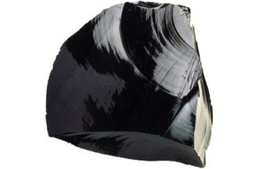
3.  Andesite | Convergent  (Subduction Zone) | Fledspar, hornblende, biotite, augite | Fine  (fine to mixed) | Extrusive | Hornfels | Abundant extrusive subduction zone rock  Crushed construction stone | -Light and dark colored minerals  -Medium gray  -Fine grain | 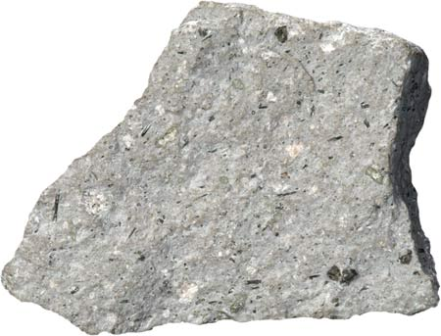
4.  Basalt | -Divergent  -Hotspot | Labradorite, augite, olivine | Fine | Extrusive | Amphibolite | Oceanic Crust  (e.g., Hawaiian hotspot) | -Can be vesicular (holey)  -Very dark gray to black | 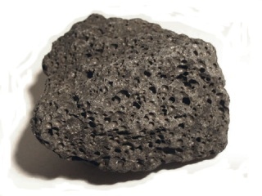
5.  Granite | Convergent  (Subduction zone) | Quartz, biotite, feldspar, hornblende | Coarse | Intrusive | Gneiss | Continental Crust  (most abundant) | -Coarse grains  -Visible quartz | 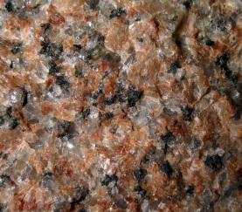
Sedimentary Rocks (p. 102-106)
Name | Diagnostic Feature | Grain Shape  (weathered/rounded or not weathered/jagged) | Grain Size  (fine, coarse, or nonvisible) | Rock Type  (clastic, organic, or chemical) | Origin  (Quiet or Active Environment and description of env.) | Daughter Metamorphic Rock  (turns into) | Composition  (What the rock is made of) | Importance or Use | Picture of Rock  (be sure to color)
1.  Coal (Bituminous) | -Black  -Brittle  -Shiny & dull layers  -Dirty to handle | Nonvisible | Medium to Fine | Organic | Quiet Env.  Wetlands,  Bogs, Swamps  (fossilized peat: 100-300 mya) | Anthracite (metamorphic coal) | Plants  (i.e., peat)  -Hydrocarbons | -Fossil Fuel  (burned to make electricity – makes 60% of U.S. electrical need) | 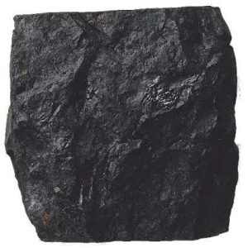
2.  Conglomerate | -Made of pebbles/  gravel  -Looks like concrete | Rounded  (highly weathered) | Coarse  (variable  matrix) | Clastic | Active environment  River or shoreline |  | Gravel,  pebbles | No economic importance | 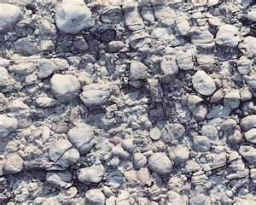
3.  Shale | -Banded grain pattern (foliated)  -Gray to Red | Jagged | Fine | Clastic  (clay particles) | Quiet environment (lakebed, lagoon, swamp, ocean basin) | Slate | Clay minerals | -Most abundant sedimentary rock  - Fracking for oil/natural gas  -Building material  -Finding fossils & understanding Earth’s history | 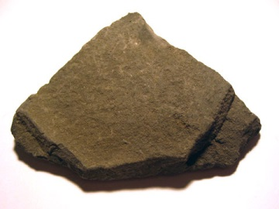
4.  Limestone | Reactive to Acid/HCl  (Carbonate)  -White to pink | Jagged | Fine | Chemical | Quiet environment  Lake, sea, or underground water/caves | Marble | Calcite minerals | -Building material  -Making cement  -Finding fossils & understanding Earth’s history | 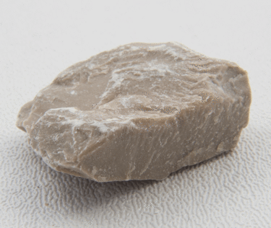
5.  Sandstone  (Quartz Sandstone) | -Grains of quartz  -Looks like glued sand  -White to red | Round  (highly weathered) | Fine  (to coarse) | Clastic | Active environment  beach or desert | Quartzite | Quartz minerals  (silica) | -Building material  -Making glass | 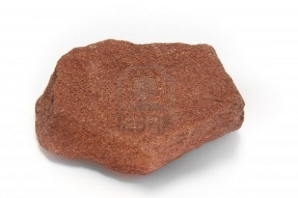

Metamorphic Rocks (p. 110-112)
Name | Diagnostic Feature | Grain Pattern  (foliated or nonfoliated) | Grain Shape  (round, jagged, or not visible) | Plate Boundary  (Con., Div., Trans., Hotspot) | Contact or  Regional Metamorphism | Parent Igneous or Sedimentary Rock  (was) | Importance or Use | Picture of Rock  (be sure to color)
1.  Quartzite | -Looks like melted sugar  -Fine to coarse | Nonfoliated (nonbanded) | Round | -Primarily Convergent  (Subduction zone)  -Transform | Regional  (rarely contact) | Sandstone | -Building material  -Glass ware | 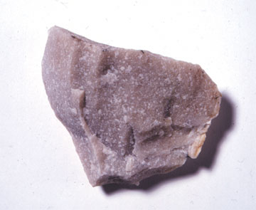
2.  Slate | -Foliated (banded pattern)  -Slaty cleavage | Foliated (banded) | Jagged | -Convergent  -Transform | Regional | Shale | -Roofing, tiles, blackboards | 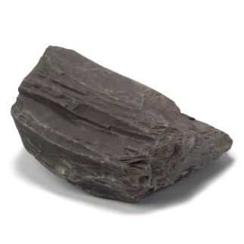
3.  Marble | Reactive to Acid/HCl (Carbonate)  -Coarse grains | Nonfoliated | Jagged | -Primarily Convergent  Subduction zone  -Transform | Regional  or Contact | Limestone | -Monuments, statues  -Building material  -old tombstones | 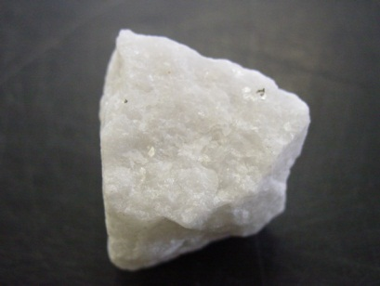
4.  Gneiss | -Foliated (banded grain patter)  Alternating light/dark bands | Foliated  (banded) | Jagged | -Convergent  -Transform | Regional | -Granite  -Schist | No good economic use | 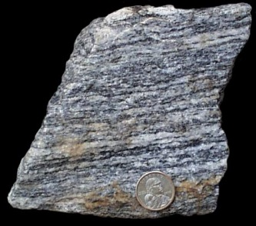
5.  Schist | -Glossy luster  -Leafy, loosely layered bands | Foliated | Jagged | -Convergent  -Transform | Regional | Shale | -Interpreting geologic history of Earth | 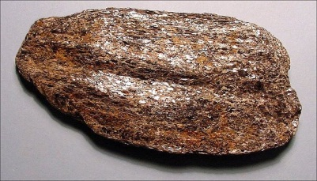

Metamorphic Rock Identification Chart
TEXTURE | FOLIATION | COMPOSITION | TYPE | PARENT ROCK | ROCK NAME
Foliated | slaty | mica | Regional | Mudstone | Slate
 | phyllitic | quartz, mica, chlorite | Regional | Mudstone | Phyllite
 | schistose | mica, quartz | Regional | Slate | Schist
 | schistose | amphibole, plagioclase | Regional | Basalt or Gabbro | Amphibolite
 | gneissic banding | feldspar, mica, quartz | Regional | Schist | Gneiss
Non-Foliated |  | carbon | Contact or Regional | Bituminous Coal | Anthracite Coal
 |  | quartz, rock fragments | Contact or Regional | Conglomerate | Metaconglomerate
 |  | calcite | Contact or Regional | Limestone | Marble
 |  | quartz | Contact or Regional | Sandstone | Quartzite

Igneous Rock Identification Chart
COMPOSITION  TEXTURE | Felsic | Intermediate | Mafic | Ultramafic
Pegmatitic | Granite Pegmatite | Diorite Pegmatite | Gabbro Pegmatite
Phaneritic | Granite | Diorite | Gabbro | Dunite
Aphanitic | Rhyolite | Andesite | Basalt
Porphyritic | Rhyolite | Andesite | Basalt
Glassy | Obsidian |  | Basaltic Glass
Vesicular | Pumice |  | Scoria
Pyroclastic | Volcanic Tuff

Sedimentary Rock Identification Chart
TEXTURE | GRAIN SIZE | COMPOSITION | ROCK NAME
Clastic | >2 mm | rounded quartz, feldspar and rock fragments | Conglomerate
 | >2 mm | angular quartz, feldspar and rock fragments | Breccia
 | 1/16 - 2 mm | quartz, feldspar | Sandstone
 | >1/16 mm | feldspar, quartz | Arkose
 | <1/16 mm | quartz, clay minerals | Siltstone  (Mudstone, Shale)
 | <1/256 mm | quartz, clay minerals | Claystone
Chemical |  | silica (quartz) | Chert
 |  | dolomite | Dolostone
 |  | calcite | Limestone
 |  | halite | Rock Salt
 |  | gypsum | Rock Gypsum
Biologic |  | silica (quartz) | Chert
 |  | loosely compacted organic material and plant fragments | Peat
 |  | densely compacted organic material and plant fragments | Bituminous Coal
 |  | calcite | Limestone
 |  | calcite, micro-skeletal fragments | Chalk
 |  | calcite, almost entirely shell and skeletal fragments | Coquina
 |  | calcite with some shell and skeletal fragments | Fossiliferous Limestone
 |  | dolomite with some shell and skeletal fragments | Fossiliferous Dolostone

Soil
E3.p1B Explain how physical and chemical weathering leads to erosion and the formation of soils and sediments. (prerequisite)
E3.p1C Describe how coastal features are formed by wave erosion and deposition.
Coral reefs

E3.p2B
Identify common igneous (granite, basalt, andesite, obsidian, pumice),
metamorphic (schist, gneiss, marble, slate, quartzite),
sedimentary (sandstone, limestone, shale, conglomerate) rocks

E3.1A Discriminate between igneous, metamorphic, and sedimentary rocks and describe the processes that change one kind of rock into another.
E3.1B Explain the relationship between the rock cycle and plate tectonics theory in regard to the origins of igneous, sedimentary, and metamorphic rocks.
E3.1c Explain how the size and shape of grains in a sedimentary rock indicate the environment of formation (including climate) and deposition.
E3.1d Explain how the crystal sizes of igneous rocks indicate the rate of cooling and whether the rock is extrusive or intrusive.
E3.1e Explain how the texture (foliated, nonfoliated) of metamorphic rock can indicate whether it has experienced regional or contact metamorphism.
