Answer Sheet
Video WS: Plate Tectonics

Layers of the Earth
- What do scientists use to learn about the inside layers of the Earth? Seismic waves from earthquakes; both P (primary) and S (secondary) waves.

- Explain the different layers of the Earth.
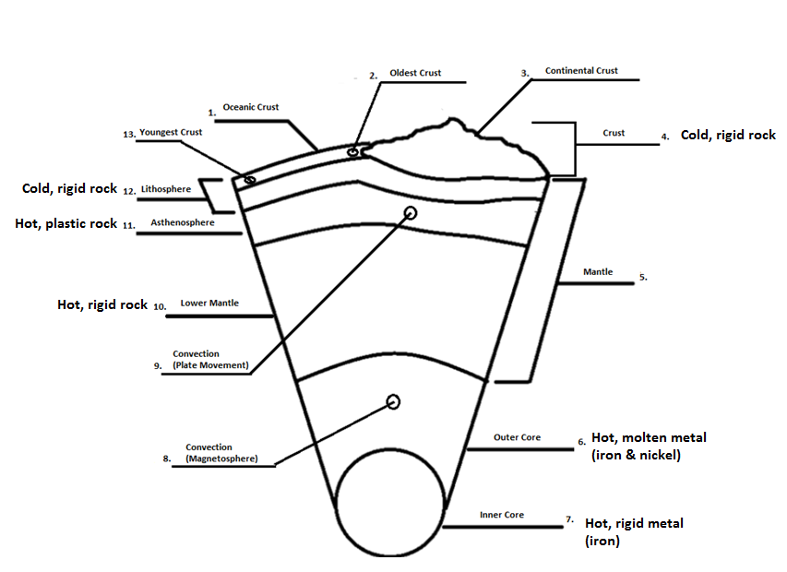

- How do scientists use seismic waves to study the layers of the Earth? They measure the speeds that the waves travel through the Earth and how much the waves deflect. The speeds of the waves tell scientists the densities and compositions of the layers. The deflections of the waves tell scientists where the layer boundaries are located. Also, they look to see if the S wave can make it through a layer; if the S wave does not travel through a layer, that layer is liquid. Secondary (S) waves do not travel through liquids (e.g., outer core).

- Why is it difficult to study the inside of the Earth? It is difficult because scientists cannot drill deep into the Earth; heat and pressure is too great. We can only drill into the crust.

- Explain the differences between the inner and outer cores.
Inner Core: Solid, rigid Metal (i.e., iron)
Outer Core: Liquid, molten metal (i.e., iron & nickel), convection currents create magnetosphere

- Why does the Earth take so long to cool off?
Because it is so large; also gravity (i.e., frictional heat) and radioactive decay add to the heat.

- Explain the difference between continental and oceanic crust.
Continental Crust: made of granite, billions of years old (i.e., 3.5 billion), light in color, less dense than mantle, makes up the continents, does not subduct, and high in silica
Oceanic Crust: made of basalt, millions of years old (i.e., 200 million), dark in color, more dense than mantle, subducts, low in silica, and makes up the ocean floor
Continental Drift
8. What is continental drift?
The hypothesis that continents slowly move across Earth’s surface
9. What was the common belief about the continents before Alfred Wegner?
They were locked in place and did not move.

10. What is Pangaea?
It is a single landmass of all the continents; supercontinent.

11. How fast do the continents move?
12. List the proof for continental drift?
- Rocks: same rock outcroppings (e.g., mountain ranges), continental margins, found on different continents
- Fossils: same freshwater and land animals found on different continents
- Climatological/Environmental Record: same historic environments found on different continents or unique historic environments found on a continent (e.g., Michigan has evidence of a past tropical environment- only possible if Michigan was once at or near equator)
- Similar Coastlines: the shapes of the contents fit together
- Magnetism: the magnet alignment of the iron in magnetite shows the previous location of the continent

13. Why do you think Alfred Wegner continued to try to prove his theory of continental drift, even though other scientists called him crazy? Why do you think he pushed on with his theory, even to the point of his own death? Why didn’t he give up?
Answers Vary

Plate Tectonics
14. Explain the theory of plate tectonics? It is the theory that pieces of the Earth’s lithosphere are in constant motion, driven by convection currents in the mantle and gravity (i.e., subduction).

15. How do scientists know where plate boundaries are located?
Earthquakes and volcanoes

16. Describe how the plates move.
The plates move because of convection currents in the mantle pushing the plates along, at mid-ocean ridges and creating new rock. This process is called sea-floor spreading. Continually, the plates are destroyed/recycled at subduction zones. This happens due to gravity pulling the old, dense rock back into the mantle.

Proof of Plate Tectonics
Sea-Floor Spreading
17. What was the common belief about the ocean floor before Harry Hess?
The ocean floor was completely flat.

18. What did Harry Hess discover?
- The ocean floor has varied topography; mountains, volcanoes, canyons, etc.
- He discovered sea-floor spreading at the mid-ocean ridge.
19. Explain how sea-floor spreading is used to prove plate tectonics.
The spreading creates new rock at the mid-ocean ridges. However, the Earth is not expanding/growing larger, so the rock must be destroyed/subducted, too. Therefore, the plates must move.

Magnetic Stripes
20. Explain how magnetic stripes are used to prove plate tectonics.
a. the stripes are the same size on both sides of the mid-ocean ridge
b. the stripes have the same polarity on both sides of the ridge
c. the polarity alternates (normal/revered) in the same pattern on both sides of the ridge
d. the newest polarized rock is at the ridge and the oldest polarity rocks are at the subduction zones

Magnetic stripes are the same size on either side of the mid-ocean ridges
At or near the crest of the ridges, the rocks are very young, and they become progressively older the further away from the mid-ridge the rock travels
The youngest rocks at the ridge crest always have present-day (normal) polarity;
Stripes of rock parallel to the ridge crest alternate in magnetic polarity (normal-reversed-normal, etc.), suggesting that they were formed during different normal and reversal episodes of the Earth's magnetic field.

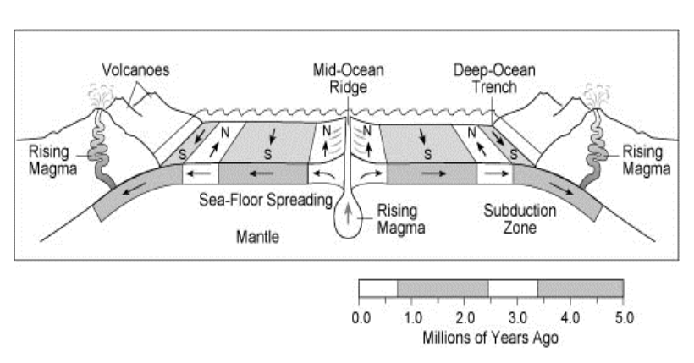
Future Earth
21. What is Pangaea Ultima?
A future supercontinent, approximately 200 million years from now (i.e., single continental landmass).

22. In the future, what will stop the plate tectonic machine?
The Earth’s core will cool and harden. The plates will not move without the core heating the mantle and causing convection currents.

23. Explain the progression of thought about plate tectonic theory before Wegner and Hess, to today.
Scientists used to believe that the continents were locked in place and did not move. Continually, they believed the ocean floor was flat. Today, geologists have proved that the ocean floor has varied topography and the plates move.

Name_____________________________________________Hour__________Date___________________
Video WS: Plate Tectonics

Layers of the Earth
- What do scientists use to learn about the inside layers of the Earth?

- Explain the different layers of the Earth.

- How do scientists use seismic waves to study the layers of the Earth?

- Why is it difficult to study the inside of the Earth?

- Explain the differences between the inner and outer cores.

- Why does the Earth take so long to cool off?

- Explain the difference between continental and oceanic crust.

Continental Drift
8. What is continental drift?
9. What was the common belief about the continents before Alfred Wegner?

10. What is Pangaea?

11. How fast do the continents move?
12. List the proof for continental drift?

13. Why do you think Alfred Wegner continued to try to prove his theory of continental drift, even though other scientists called him crazy? Why do you think he pushed on with his theory, even to the point of his own death? Why didn’t he give up?

Plate Tectonics
14. Explain the theory of plate tectonics?

15. How do scientists know where plate boundaries are located?

16. Describe how the plates move.

Proof of Plate Tectonics
Sea-Floor Spreading
17. What was the common belief about the ocean floor before Harry Hess?

18. What did Harry Hess discover?

19. Explain how sea-floor spreading is used to prove plate tectonics.

Magnetic Stripes
20. Explain how magnetic stripes are used to prove plate tectonics.

Future Earth
21. What is Pangaea Ultima?

22. In the future, what will stop the plate tectonic machine?

23. Explain the progression of thought about plate tectonic theory before Wegner and Hess, to today.

