Answer Sheet
Video WS: Magnetosphere

1. What is the magnetosphere; Earth’s magnetic shield? It is a magnetic field around the Earth extending into space. The magnetic field protects the planet from cosmic and solar radiation.

2. Draw a picture of the magnetic field.
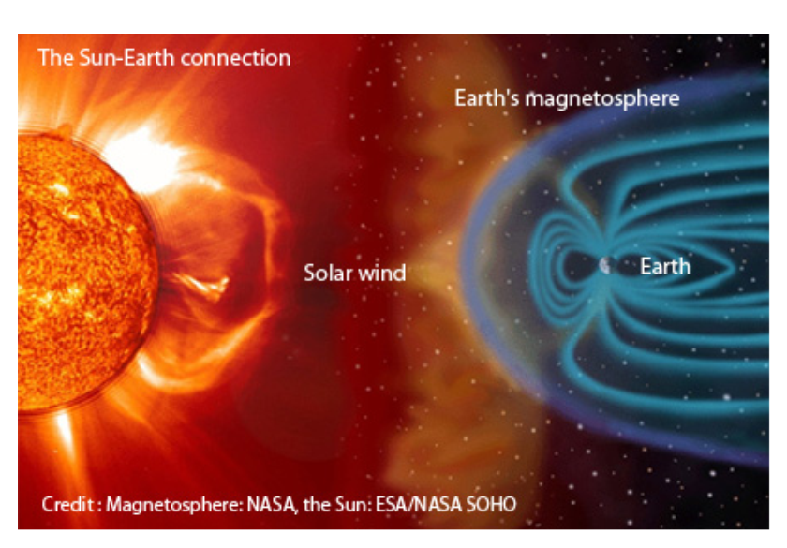

3. Where and how is the magnetosphere formed (i.e., magnetic field)?
The magnetic field is generated in the outer core. It forms when molten metal (i.e., iron & nickel) convects around the solid, iron inner core. This convection of molten metal around solid metal creates a dynamo effect. This dynamo effect creates a giant electromagnetic field (i.e., magnetic shield made by electricity).

4. Explain what and how Auroras are formed. Auroras (i.e., northern lights) are a colorful light show created by the interaction of atmospheric gas and solar radiation. The radiation from the sun is able to enter the atmosphere at zones of low magnetic field strength. Primarily these zones of weakness are at the poles (I.e., North & South Poles), because of the way the magnetic field is generated.

5. If there was no magnetic shield, what impact would cosmic and solar radiation have on the Earth?
The Earth would die, similarly to how Mars died. The absence of a magnetic field would allow solar winds to blow away the atmosphere, and then water on the surface of the planet would boil off. Finally, organic life (i.e., plants and animals) would die.

6. Describe the South-Atlantic Anomaly. It is a zone of magnetic weakness above South America/Atlantic Ocean. This is occurring because the magnetic field is going through a reversal and the magnetic lines, in this location, are flipping.

7. Explain why Mars lost its magnetic field and if the can happen to Earth. Mars lost its magnetic field because the core cooled. Without molten metal in the outer core (i.e., convection) there cannot be a magnetic field. This will happen to Earth. However, it will take a couple billion years for Earth’s core to cool; Earth cools slower because it is larger.

8. Why is it hard for geoscientists to know exactly what the inside of the Earth is like and how the magnetosphere is created? It is hard for geoscientists to know exactly what the inside of the Earth looks like because they cannot drill deep into the Earth (i.e., only a few miles into crust); the pressure and heat is too great. Therefore, they can only use seismic waves to determine what happens and what makes up the interior of Earth.

9. How do scientists use seismic waves to learn about the interior of the Earth and the magnetosphere? Scientists use the speed and deflection of the waves. The deflection tells them where a layer boundary is located. The speed of the wave tells them the composition and density of the layer. Also, S (secondary) waves cannot travel through liquids. Therefore, the absences of s-waves (i.e., shadow zone) tell scientists where the liquid outer core is located and that it is liquid.

10. Why is magnetite important in understanding the magnetic field? Magnetite is made of iron. Iron is easily magnetized. This iron in the magnetite will align itself to the magnetic field. When the field is northerly polarized the magnetite will align north (i.e., point) and when it is reversed the magnetite (i.e., iron) will point south. This flipping of magnetite’s polarization tells scientists that the magnetic poles flip or reverse.

11. Explain how scientists measure magnetite polarization to tell how the magnetic field has flipped its polarity (i.e., lines/layers of magnetism) over time. They drill out core samples in each layer of rock (i.e., cooled lava layers) and then run it through a magnetometer. This device tells the scientists in which direction the magnetite has hardened/cooled (i.e., the iron points to the magnetic pole). What they have found is magnetite flips from north polarization to south polarization every few hundred thousand years (e.g., last flip was 780,000 years ago).

12. What would be the result of the magnetic poles reversing?
The magnetic field would be weakened; increased cancer (e.g., eye/skin), animal directional problems (e.g., whale beaching), and technology issues (e.g., satellite malfunction).

13. How often or how many times have the magnetic poles flipped/switched polarity (i.e., N/S)?
Every few hundred thousand years; last time 780,000 years ago.

14. What would happen to technology, animals, and people if the magnetosphere was to disappear? Mention all three.
Increased cancer for people (e.g., eye/skin), animal directional problems (e.g., whale beaching), and technology issues (e.g., satellite malfunction).

15. There are polarized layers or lines of rock on the ocean floor that have iron (e.g., magnetite) in them. Some layers are polarized north and some polarized south. Explain why this is occurring and how this can be used to prove the sea-floor is spreading (i.e., plate tectonics).
When the lava containing magnetite cools the iron in the rock solidifies in the direction of the pole. When the Earth is northerly polarized the iron points north and when it is southerly polarized the iron points south. This reversal shows up in layers on the ocean floor. As new magnetite forms at a mid-ocean ridge it aligns to the polarization of that time period. The alternating layers of polarization prove that the sea-floor is growing. If it was not, the rock would all be one single polarization (e.g., north).

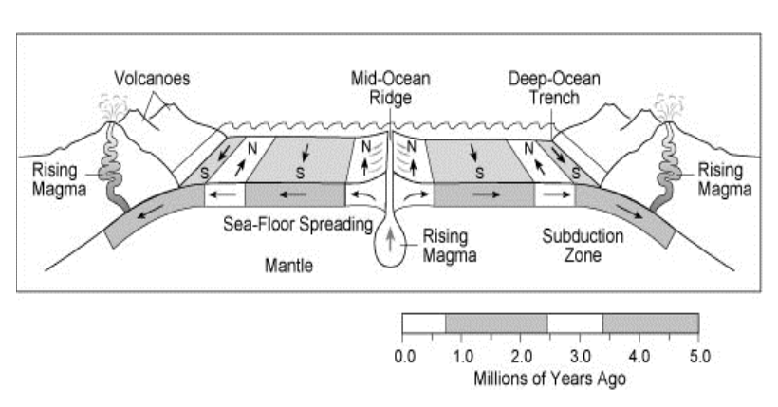
- Magnetic stripes are the same size on either side of the mid-ocean ridges
- At or near the crest of the ridges, the rocks are very young, and they become progressively older the further away from the mid-ridge the rock travels
- The youngest rocks at the ridge crest always have present-day (normal) polarity;
- Stripes of rock parallel to the ridge crest alternate in magnetic polarity (normal-reversed-normal, etc.), suggesting that they were formed during different normal and reversal episodes of the Earth's magnetic field.

16. Predict the future of the Earth. Describe your answer in scientific detail.
The Earth will cool, causing the asthenosphere and outer core to harden. This will stop plate tectonics and the dynamo effect (i.e., magnetic field). The loss of the magnetic field will cause the atmosphere to be blown away, water to boil away, and organic material to die. The stopping of plate tectonics will end continental drift, earthquakes, and volcanic eruptions. The Earth will look like a larger version of Mars. (Don’t worry, it will take a couple billion years.)

Magnetosphere Pre-Movie Quiz

- At this point, scientists have not found evidence to show that Earth's magnetic field is getting weaker.
True False

- The loss of Mars' magnetic shield was most likely due to a cooling core. This caused tectonic activity to stop and the sun's solar winds to blow off the atmosphere; killing the planet.
True False

- The magnetic poles are not currently in a reversal state.
True False

- The magnetosphere is created by the gravitational pull between the Earth and the moon.
True False

- The magnetic poles are in the same location as the geographic poles.
True False

- The interaction between the iron of the churning (i.e., spinning convection currents) molten outer core and the iron of the solid metal inner core create a dynamo effect. This dynamo results in our planet having a magnetosphere.
True False

- If the magnetic field of the Earth was to be weakened, high levels of solar radiation would make it to our planet. This solar radiation can cause the mutation of cells in humans and lead to cancer. (e.g., eye and skin cancer)
True False

- Scientists use seismic waves from earthquakes to study the layers of the Earth.
True False

- All of the following things would result from the magnetosphere slowly disappearing, EXCEPT for which one thing? (i.e., one thing is not true… which one is it?)
- The oceans, lakes, and streams of Earth would boil off.
- Solar winds would blow away Earth’s atmosphere.
- Some animals would not be able to navigate and find their way (e.g. whales, bats).
- Earthquakes would intensify and destroy whole cities.
- The Earth would freeze and turn into a lifeless, barren rock.

- Magnetite (i.e., iron) in rock will orient itself to the magnetic north or south poles. Scientists use the flipping of this polarization to prove the sea-floor is spreading.
True False

- The magnetic poles flip/reverse places every few hundred thousand years. Magnetic north becomes magnetic south. The last time this took place was about 780 thousand years ago.
True False

- Auroras are a colorful light show (i.e., northern lights) in the sky caused by solar radiation making it to our atmosphere, and the radiation interacting with the gases.
True False

Name__________________________________________Hour_______________Date__________________

Video WS: Magnetosphere
Answer these questions on a sheet of lined paper. Restate the question in your answer.

NOTE: Leave space between each question, even after you answered the question. The information will build throughout the movie and you will want to go back and add information.

1. What is the magnetosphere; Earth’s magnetic shield?

2. Draw a picture of the magnetic field.

3. Where and how is the magnetosphere formed (i.e., magnetic field)?

4. Explain what and how Auroras are formed.

5. If there was no magnetic shield, what impact would cosmic and solar radiation have on the Earth?

6. Describe the South-Atlantic Anomaly.

7. Explain why Mars lost its magnetic field and if the can happen to Earth.

8. Why is it hard for geoscientists to know exactly what the inside of the Earth is like and how the magnetosphere is created?

9. How do scientists use seismic waves to learn about the interior of the Earth and the magnetosphere?

10. Why is magnetite important in understanding the magnetic field?

11. Explain how scientists measure magnetite polarization to tell how the magnetic field has flipped its polarity (i.e., lines/layers of magnetism) over time.

12. What would be the result of the magnetic poles reversing?

13. How often or how many times have the magnetic poles flipped/switched polarity (i.e., N/S)?

14. What would happen to technology, animals, and people if the magnetosphere was to disappear? Mention all three.

15. There are polarized layers or lines of rock on the ocean floor that have iron (e.g., magnetite) in them. Some layers are polarized north and some polarized south. Explain why this is occurring and how this can be used to prove the sea-floor is spreading (i.e., plate tectonics).

16. Predict the future of the Earth. Describe your answer in scientific detail.

Magnetosphere Pre-Movie Quiz

- At this point, scientists have not found evidence to show that Earth's magnetic field is getting weaker.
True False

- The loss of Mars' magnetic shield was most likely due to a cooling core. This caused tectonic activity to stop and the sun's solar winds to blow off the atmosphere; killing the planet.
True False

- The magnetic poles are not currently in a reversal state.
True False

- The magnetosphere is created by the gravitational pull between the Earth and the moon.
True False

- The magnetic poles are in the same location as the geographic poles.
True False

- The interaction between the iron of the churning (i.e., spinning convection currents) molten outer core and the iron of the solid metal inner core create a dynamo effect. This dynamo results in our planet having a magnetosphere.
True False

- If the magnetic field of the Earth was to be weakened, high levels of solar radiation would make it to our planet. This solar radiation can cause the mutation of cells in humans and lead to cancer. (e.g., eye and skin cancer)
True False

- Scientists use seismic waves from earthquakes to study the layers of the Earth.
True False

- All of the following things would result from the magnetosphere slowly disappearing, EXCEPT for which one thing? (i.e., one thing is not true… which one is it?)
- The oceans, lakes, and streams of Earth would boil off.
- Solar winds would blow away Earth’s atmosphere.
- Some animals would not be able to navigate and find their way (e.g. whales, bats).
- Earthquakes would intensify and destroy whole cities.
- The Earth would freeze and turn into a lifeless, barren rock.

- Magnetite (i.e., iron) in rock will orient itself to the magnetic north or south poles. Scientists use the flipping of this polarization to prove the sea-floor is spreading.
True False

- The magnetic poles flip/reverse places every few hundred thousand years. Magnetic north becomes magnetic south. The last time this took place was about 780 thousand years ago.
True False

- Auroras are a colorful light show (i.e., northern lights) in the sky caused by solar radiation making it to our atmosphere, and the radiation interacting with the gases.
True False

