Name___________________________________________________________________Hour__________Date______________
Water Quality Test: Data Table
Sample # | Location Retrieved | Fresh, Brackish, or Seawater | GPS Coordinates  Lat: N or S  Long: E or W | Temperature  (ºC) | pH  (pH units) | Turbidity  (NTU) | Visual/Microscopic Test  (observed organisms or material) | Total Dissolved Solids  (mg/L) | Salinity  (ppt)
#1 |  |  | Longitude  Latitude | Day 1  Day 2
#2 |  |  | Longitude  Latitude | Day 1  Day 2
#3 |  |  | Longitude  Latitude | Day 1  Day 2
Sample #: Use multiple boxes if you collected multiple water samples.
Location Retrieved: Be as specific as possible (e.g., River Raisin). Stream, river, creek, pond, quarry, lake, ocean, wetland, swamp, bog, aquifer (e.g., well, artesian, or spring), rain, puddle, runoff, etc.
Fresh, Salt, or Brackish: This refers to the amount of salt (i.e., salinity) in the water. Brackish water or briny water is water that has more salinity than fresh water, but not as much as seawater.
Note: Be sure to label the correct units (e.g., ppm, cm, ml, ºC).
GPS Coordinates
Note: You may use a WiFi enabled device for the GPS Coordinates lab.
Introduction
A geographic coordinate system is a coordinate system that enables every location on the Earth to be specified by a set of numbers or letters. The coordinates are often chosen such that one of the numbers represents vertical position, and two or three of the numbers represent horizontal position. A common choice of coordinates is latitude, longitude and elevation.
Latitude: North of the equator the unit lab is N and south of the equator it is S.
Longitude: A line passing near the Royal Observatory, Greenwich (near London in the UK) has been chosen as the international zero-longitude reference line, the Prime Meridian. Places to the east are in the eastern hemisphere, and places to the west are in the western hemisphere. Negative (-) longitude readings are labeled W and positive longitude readings are labeled E.
Materials Checklist
___ WiFi enabled device or computer

Testing Procedure
  - Go to the website
    - http://itouchmap.com/latlong.html
  - Move the red marker to the location where you collected your water sample
  - Continue to zoom in and move the red marker
    - zoom is the + sign to the left
  - Change the from map setting to satellite
    - Click the satellite button on the top right
  - Continue to zoom in and move the red marker
  - Once you have the exact location of water collection, record the longitude and latitude on your data table
  - You will find the longitude and latitude in the bottom left corner
    - It is recorded in degrees, minutes, and seconds
  - Properly label latitude units as either N (north) or S (south) of the equator
  - Properly label longitude units as either E (i.e., east of Prime Meridian) or W (i.e., west of Prime Meridian)
Questions
- Why will your longitude reading be a negative number?
- For latitude, what do N and S stand for?
- For longitude, what do W and E represent?
Water Temperature Test
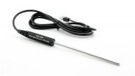
Introduction
The temperature of a body of water influences its overall quality. Water temperatures outside the “normal” range for a stream or river can cause harm to the aquatic organisms that live there. It is for this reason that the change in the temperature of the water over a section of a stream is measured, not just the temperature at one location. If the water temperature changes by even a few degrees over a one-mile stretch of the stream, it could indicate a source of thermal pollution
Water temperature
Aquatic organisms are dependent on certain temperature ranges for optimal health. Temperature affects many other parameters in water, including the amount of dissolved oxygen available, the types of plants and animals present, and the susceptibility of organisms to parasites, pollution and disease. Causes of temperature changes in the water include weather conditions, shade and discharges into the water from urban sources or groundwater inflows. Temperature is measured in degrees Celsius (°C). Seasonal trends: May to October: 22 to 35°C, November to April: 2 to 27°C

Materials Checklist
___ LabQuest ___ Vernier Temperature Probe ___ Dixie cup ___Paper towel for cleanup

Testing Procedure
1. Position the LabQuest safely away from the water. Keep water away at all times.
2. Make sure your sensor matches the one you are monitoring on the LabQuest.
3. You are now ready to collect temperature data.
a. Pour some of your sample water into a Dixie cup. Only use enough water to get a temperature reading. Remember to use your water sparingly.
4. Submerge the probe in the Dixie cup.
a. Do not put the probe in your sample bottle; you will contaminate your sample!
b. Wait until the probe equalizes and get your data.
5. Clean up: Dry the temperature probe and the table with paper towel. Dispose of the Dixie cup.
6. Record your temperature value on the Data Table, in Celsius.

Questions
- Explain thermal pollution.
- What impact(s) does temperature have on dissolved oxygen levels?
- When doing water quality testing, why is temperature important?
- Study “Table 1: Optimal Temperature Ranges” - What is the best (i.e., optimal) temperature for many freshwater fish?
- Is there anything that could have had an impact on your temperature readings (i.e., variables)? Explain!

pH Test

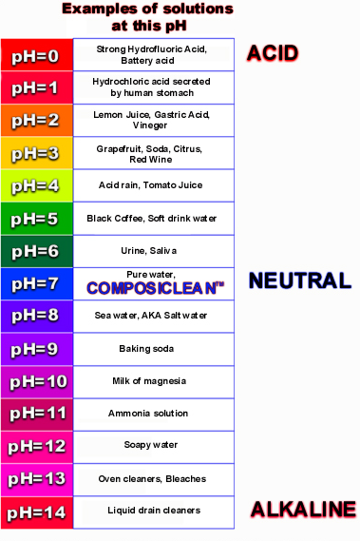
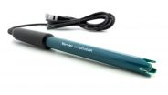
Introduction
A pH test measures the alkalinity or acidity concentration in water. A pH of 7 is neutral, below 7 is acidic, and above 7 is basic or alkaline. Acid rain, from auto exhaust or coal-fired power plants, causes a drop in the pH of water. Pollution from accidental spills, agricultural runoff and sewer overflows can also change the pH. Buffering capacity is water's ability to resist changes in pH, and is critical to the survival of aquatic life. The limestone soils of Central Texas act to neutralize these acids and often result in a more basic pH. While young fish and insect larvae are sensitive to a low pH (acid), extreme values on either end of the scale can be lethal to most organisms. Pure water has a pH very close to 7 at 25 °C. Expected levels: 6.5 to 9.0

Materials Checklist
___ LabQuest ___ wash bottle with distilled water ___ Vernier pH Sensor
___ Cotton towel ___ Wastewater bucket or container ___ Dixie cup

Testing Procedure
1. Position the LabQuest safely away from the water. Keep water away at all times.
2. Make sure your sensor matches the one you are monitoring on the LabQuest.
3. You are now ready to collect pH data.
a. Rinse the tip of the sensor thoroughly with distilled water (i.e., glass bulb).
- Rinse over wastewater container or bucket
- Do not rinse sensor up to black handle, you will break sensor.
b. Very gently, dry the entire sensor with a cotton towel.
- The sensor must be dry or excess water will dilute sample!
DO NOT SCRATCH OR BREAK THE GLASS OF THE SENSOR! ONLY USE CLEAN TOWELS.

4. Mix the water in the sample bottle by gently shaking.
a. Pour 4-5 cm of your water into a new & dry Dixie cup.
a. Submerge sensor and gently swirl the sensor in the sample water (i.e., in Dixie cup).
b. Wait until the sensor equalizes and get your data.
5. Record your pH value on the Data Table, in units of pH.
6. Clean up: Rinse the sensor with distilled water and dry with cotton towel. Throw away Dixie cup.

Questions
- Write a definition for pH.
- When doing water quality testing, why is pH important?
- Explain your field observations. What did your collection site look like?
-e.g., weather, geography, minerals, vegetation along stream, city, farmland, etc.
- Was your sample alkaline (basic), neutral, or acidic? What do you think caused its pH?
- Is there anything that could have had an impact on your pH readings (i.e., variables)? Explain!
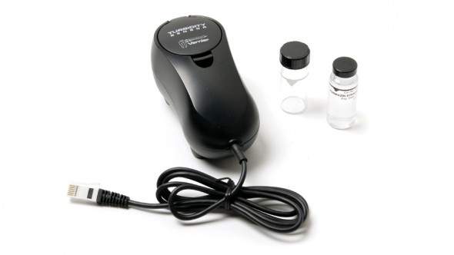
Turbidity Test

Introduction
Turbidity is a measure of water’s lack of clarity (i.e., transparency). Water with high turbidity is cloudy, while water with low turbidity is clear. The cloudiness is produced by light reflecting off of particles in the water; therefore, the more particles in the water, the higher the turbidity. Many factors can contribute to the turbidity of water. An increase in stream flow due to heavy rains or a decrease in stream-bank vegetation can speed up the process of soil erosion. This will add suspended particles, such as clay and silt, to the water.

Materials Checklist
___ LabQuest ___ cotton towel (lint free) ___ Turbidity Standard (StableCal® Formazin Standard 100 NTU)
___ Vernier Turbidity Sensor ___ Cuvette (glass bottle with lid) ___ Wastewater bucket or container ___ wash bottle with distilled water

Testing Procedure
1. Position the LabQuest safely away from the water. Keep water away at all times.
2. Make sure your sensor matches the one you are monitoring on the LabQuest.
3. Rinse the cuvette (i.e., glass bottle) with some of your sample water. Use your sample water to clean the cuvette, so you do not dilute the sample.
4. You are now ready to collect turbidity data.
a. Fill the cuvette with sample water so that the bottom of the meniscus is even with the top of the white line.
b. Gently invert the sample water to mix in any particles that may have settled to the bottom.
Important: Do not shake the sample. Shaking will introduce tiny air bubbles that will affect turbidity.
c. Check the cuvette for air bubbles. If air bubbles are present, gently tap the bottom of the cuvette on a hard surface to dislodge them.
d. Gently wipe the outside with a soft, lint-free cloth or tissue. The glass must be crystal clean!
- DO NOT SCRATCH OR BREAK THE GLASS OF THE CUVETTE!
e. Holding the cuvette by the lid, place it into the Turbidity Sensor. Make sure the white arrows on the cuvette and Turbidity Sensor line up.
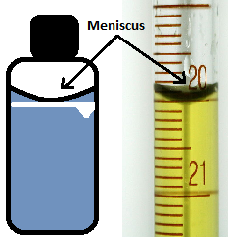
f. Close the lid of the Turbidity Sensor.
g. Wait until the sensor equalizes and get your data. Note: Do not wait long; you do not want the water to settle.
4. Record your turbidity value on the Data Table, in NTU units.
Note: Particles in the water will settle over time and show a slow downward drift in turbidity readings. Therefore, start data collection soon after placing the cuvette in the sensor.
5. When readings have been taken, rinse the cuvette with distilled water and clean up the table with paper towel. Do not use the cotton towels to clean tables.

Questions
- Write a definition for turbidity.
- When doing water quality testing, why is turbidity important?
- Explain your field observations. What did your collection site look like?
-e.g., weather, geography, stream flow, city, farm
- Is there anything that could have had an impact on your turbidity readings (i.e., variables)? Explain!
- What are the effects of turbidity? (Read the lab packet!)

Visual, Scent, and Microscopic Tests
Introduction

Color of water: The presence of color in water does not necessarily indicate that the water is not potable (i.e., drinkable). Color-causing substances such as tannins may be harmless. Color is not removed by typical water filters; however, slow sand filters can remove color.
Other factors can affect the color we see:
- Particles and solutes can absorb light, as in tea or coffee. Green algae in rivers and streams often lend a blue-green color. The Red Sea has occasional blooms of red Trichodesmium erythraeum algae.
- Particles in water can scatter light. The Colorado River is often muddy red because of suspended reddish silt in the water. Some mountain lakes and streams with finely ground rock, such as glacial flour, are turquoise. Light scattering by suspended matter is required in order that the blue light produced by water's absorption can return to the surface and be observed. Such scattering can also shift the spectrum of the emerging photons toward the green, a color often seen when water laden with suspended particles is observed.
Odor of water: The odor of water can give indication to decomposing organic material and dissolved substances. For example, the dissolved mineral sulfur can make water smell like rotten eggs.
Organic material in water: Parasites and other biological material (e.g., plants, animals, and algae) can also been seen in water. Common global water-related diseases caused by parasites include Guinea worm, schistosomiasis, amebiasis, cryptosporidiosis (Crypto), and giardiasis. People become infected with these diseases when they swallow or have contact with water that has been contaminated by certain parasites.

Materials Checklist
___ LabQuest ___ Paper towel ___ Glass slide ___ Microscope ___ Wastewater bucket or container ___ Wash bottle with distilled water ___ Pipette

Testing Procedure
- Thoroughly wash a glass slide with distilled water and then thoroughly dry with a paper towel.
- Thoroughly wash a pipette with distilled water and then thoroughly dry with a paper towel. Extra water in the pipette will dilute the sample.
- Look at the sample under the microscope.
- Draw a picture of what you observed, on the Data Table.
- Clean up: Wash and dry the glass slide and pipette.
Questions
- When doing water quality testing, why is a visual test important?
- What can you learn from a visual test?

Total Dissolved Solids Test
Introduction
The specific conductance test measures the ability of water to pass an electrical current. Conductivity in water is affected by the presence of inorganic dissolved solids such as chloride, sulfate, sodium, calcium and others. Conductivity in streams and rivers is affected by the geology of the area through which the water flows. Streams that run through granite bedrock will have lower conductivity, and those that flow through limestone and clay soils will have higher conductivity values. High conductance readings can also come from industrial pollution or urban runoff -- water running off of streets buildings, and parking lots. Extended dry periods and low flow conditions also contribute to higher specific conductance readings. Because an organic compound such as oil does not conduct electrical current very well, an oil spill tends to lower the conductivity of the water. Temperature also affects conductivity; warm water has a higher conductivity.

Materials Checklist
___ LabQuest ___ Wash bottle with distilled water ___ Vernier conductivity probe ___ Paper towel ___ Wastewater bucket or container ___ Dixie cup

Testing Procedure
1. Position the LabQuest safely away from the water. Keep water away at all times.
2. Make sure your sensor matches the one you are monitoring on the LabQuest (i.e., TDS). Note: You’re measuring total dissolved solids.
3. You are now ready to collect TDS data.
a. Rinse the tip of the sensor thoroughly with distilled water.
- Rinse over wastewater container or bucket
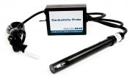
- Do not rinse sensor up to black handle, you will break the sensor.
b. Very gently, dry the entire sensor with a paper towel.
- The sensor must be dry or excess water will dilute sample!
4. Mix the water in the sample bottle by gently shaking.
a. Pour 4-5 cm of your water into a new & dry Dixie cup.
a. Submerge sensor and gently swirl the sensor in the sample water (i.e., in Dixie cup).
- The hole near the tip of the probe should be completely covered.
b. Wait until the sensor equalizes and get your data.
5. Record your TDS value on the Data Table, in units of mg/L (i.e., milligrams per liter).
6. Clean up: Rinse the sensor with distilled water and dry with paper towel. Throw away Dixie cup.

Questions
- Write a definition for TDS?
- Why is it important to know the total dissolved solids, when doing water quality testing?
- What is the typical TDS reading for lakes and streams, in mg/L?
- What can affect the level of TDS?
- Was your TDS level high or low? Think about the variables (e.g., collection site, temp., etc.), and explain what may have caused your readings.

Salinity Test

Materials Checklist
___ LabQuest ___ Wash bottle with distilled water ___ Vernier conductivity probe ___ Paper towel ___ Wastewater bucket or container ___ Dixie cup

Testing Procedure
1. Position the LabQuest safely away from the water. Keep water away at all times.
2. Make sure your sensor matches the one you are monitoring on the LabQuest (i.e., labeled salinity). Note: You’re measuring salinity.
3. You are now ready to collect salinity data.
a. Rinse the tip of the sensor thoroughly with distilled water.
- Rinse over wastewater container or bucket
- Do not rinse sensor up to black handle, you will break the sensor.
b. Very gently, dry the entire sensor with a paper towel.
- The sensor must be dry or excess water will dilute sample!
4. Mix the water in the sample bottle by gently shaking.
a. Pour 4-5 cm of your water into a new & dry Dixie cup.
a. Submerge sensor and gently swirl the sensor in the sample water (i.e., in Dixie cup).
- The hole near the tip of the probe should be completely covered.
b. Wait until the sensor equalizes and get your data.
5. Record your salinity value on the Data Table, in units of ppt (i.e., parts per trillion).
6. Clean up: Rinse the sensor with distilled water and dry with paper towel. Throw away Dixie cup.

Questions
- Write a definition for salinity.
- What are the factors that can increase or decrease salinity in ocean waters?
- What is the average salinity reading (i.e., ppt) for a freshwater river?

